**Ayesha Zubair**

**52916**

**Lab 4**

**Creating file named atomic-notes:**

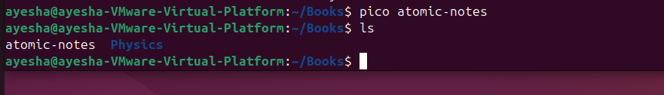

**Task 1: Rename atomic-notes to at-notes**

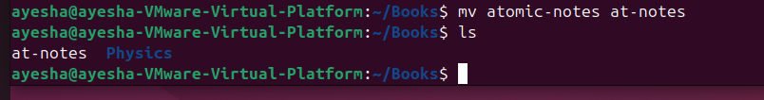

**Task 2: Moving the file to Nuclear under Physics**

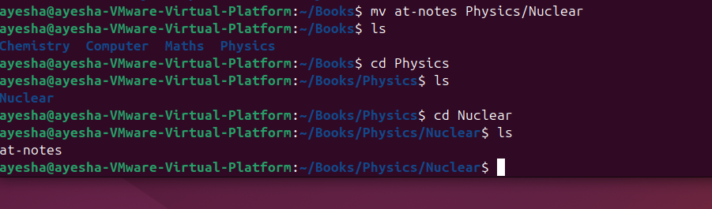

**Task 3:** Removed Write(w) permission for owner (user) from file result.comp.

Group and other get execute access for file stock.

Set group access for reading(r) and execute(x) of myfile.

**Creating file: result.comp.**

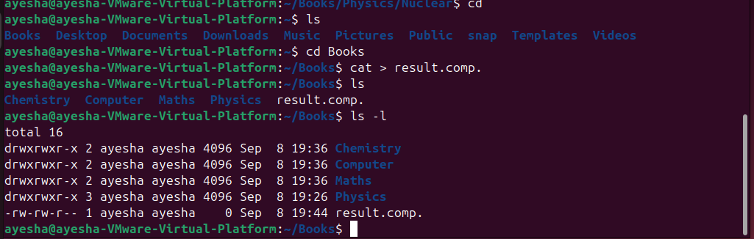

**Removing the “write” permission:**

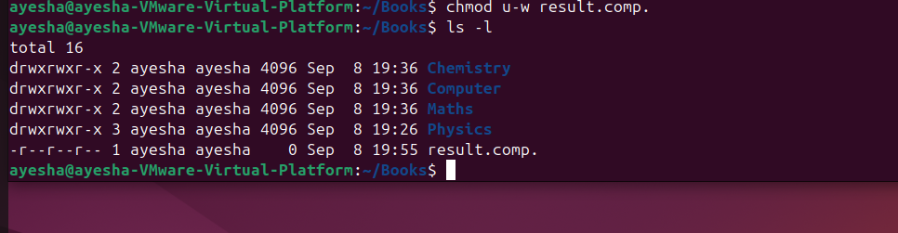

**Creating file: stock**

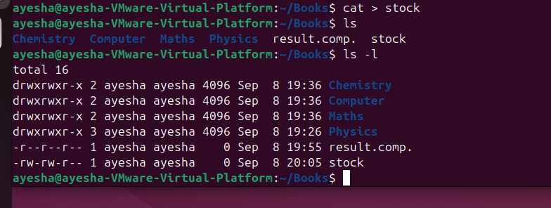

**Group and other get execute access for file stock.**

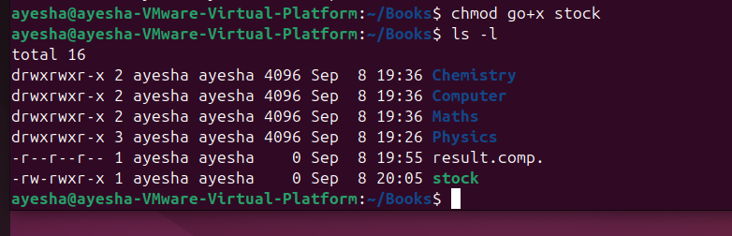

**Creating file: myfile**

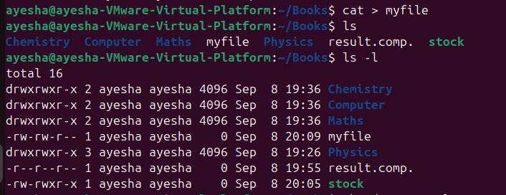

**Set group access for reading(r) and execute(x) of myfile.** 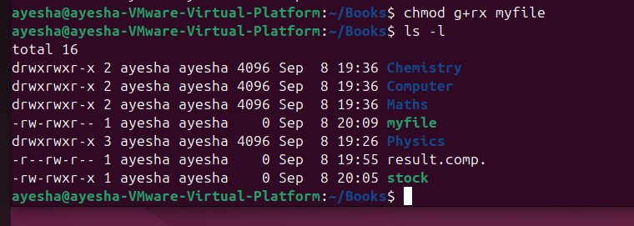

**Task 4:** Create a directory called lab4 and create three files say quiz, report and viva inside the directory

Now try to set the following rights;

-rw- r-- r- quiz

-rw- -w- r- - report

-rwx rwx r-x viva

Also try to change access permission of lab4 directory as well and see how it affects.

**Creating directory “lab4”:**

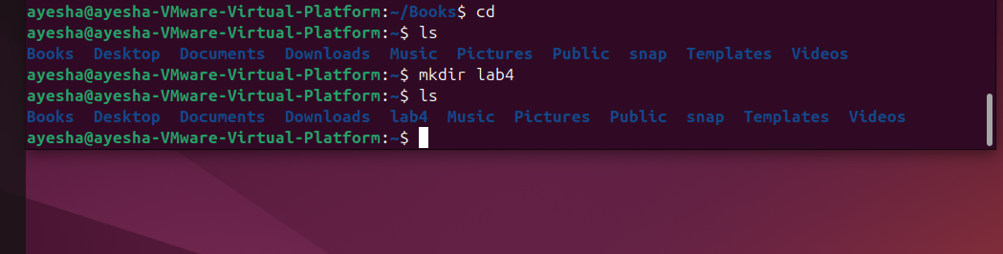

**Creating file: quiz, report and viva**

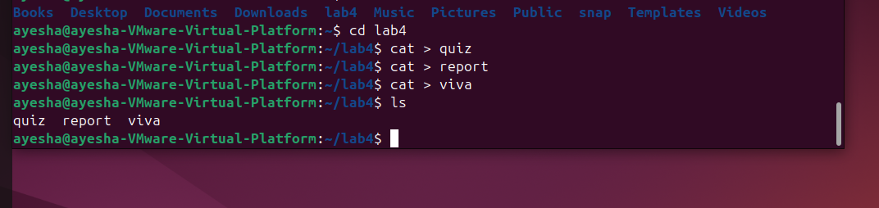

**Default:**

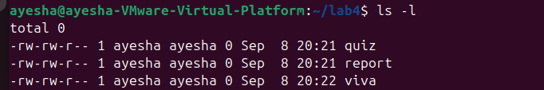

**Permission: -rw- r-- r- quiz**

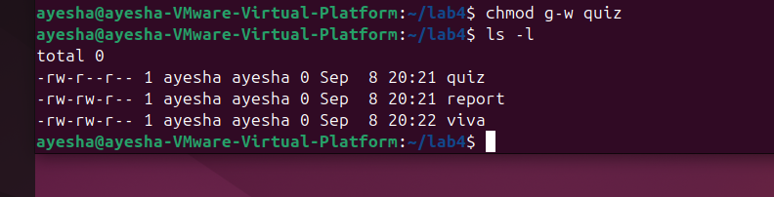

**Permission: -rw- -w- r- - report**

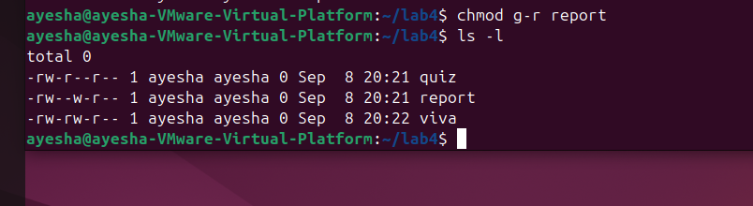

**Permission: -rwx rwx r-x viva**

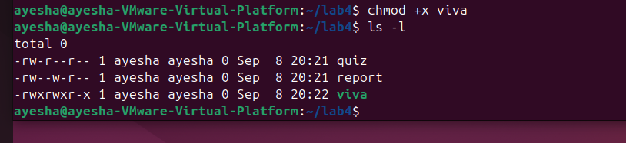

Also try to change access permission of **lab4** directory as well and see how it affects.

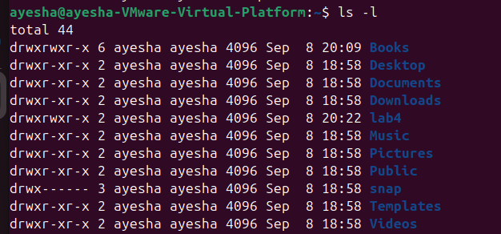

**Removing write permission:**

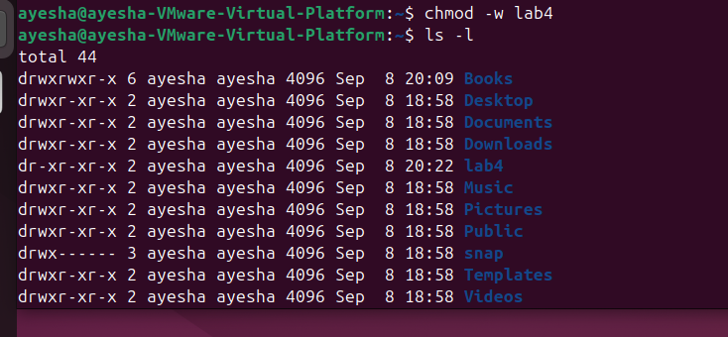

**Giving all permissions:**

